SY B.Tech. – ARTIFICIAL INTELLIGENCE AND MACHINE LEARNING
PRACTICAL ASSIGNMENT TEMPLATE

1. Student Details
Student Name | Pratik Akrur Pandit
PRN | 202501110116
Division | B2
Batch | B
Roll No. | 202501110116
Date of Submission | 16/10/2026

2. Practical Details
Practical No. | 4
Practical Title | DYNAMIC MEMORY
Date Performed
Faculty Name | Shruti Gadewar

3. Problem Statement
write a C++ program that demonstrates pointers and references and performs dynamic memory allocation and
deallocation using new and delete[] to manage student marks.

4. Objectives
- To understand and implement pointers and references in C++.
- To allocate memory dynamically using the new operator.
- To release dynamically allocated memory using the delete[] operator.

5. Expected Learning Outcomes
- Understand how pointers store and access memory addresses.
- Use references to modify existing variables.
- Manage dynamic memory efficiently using new and delete[].

6. Theory / Concept
Pointers: A pointer is a variable that stores the memory address of another variable. In this program, a pointer is used to access the marks of students.
References: A reference is another name for an existing variable. In this program, a reference is used to add bonus marks to the first student.
Dynamic Memory Allocation: Dynamic memory allocation allows memory to be allocated during program execution according to the user's requirements. The new operator allocates memory, while delete[] releases memory allocated for an array.
Real-life application: A college can use this concept to store marks for a variable number of students.

7. Algorithm / Pseudocode
Write the step-by-step algorithm or pseudocode for the proposed solution.

START
- Accept the number of students.
- Allocate memory dynamically using new.
- Input and display student marks using pointers.
- Use a reference to add bonus marks to the first student.
- Release memory using delete[]. STOP

08. Technology / Tools / Libraries Used
Technology / Tool | Purpose
Programming Language | C++
IDE / Platform | VS Code
Libraries / Packages | iostream

09. Implementation / GitHub Repository
Particular | Details
GitHub Repository URL | https://github.com/panditpratik/OOP-/issues/1
Repository Name | Problem-Solving-Using-OOP-in-Cpp-
Branch Used | main
Commit ID / Latest Commit | 0ab5780
Date of Last Commit | 15 0ct

10. Test Cases / Input and Output
Test Case | Input | Expected Output | Actual Output | Status
1 | 3 students: 75, 80, 90 | Marks: 75, 80, 90 | Marks: 75, 80, 90 | Pass
2 | First student marks: 75 | Marks after bonus: 80 | Marks after bonus: 80 | Pass
3 | 2 students: 60, 70 | Marks: 60, 70 | Marks: 60, 70 | Pass
4 | Number of students: 0 | Invalid input | Invalid input | Pass
5 | Number of students: -2 | Invalid input | Invalid input | Pass

11. Results / Observations
Input:
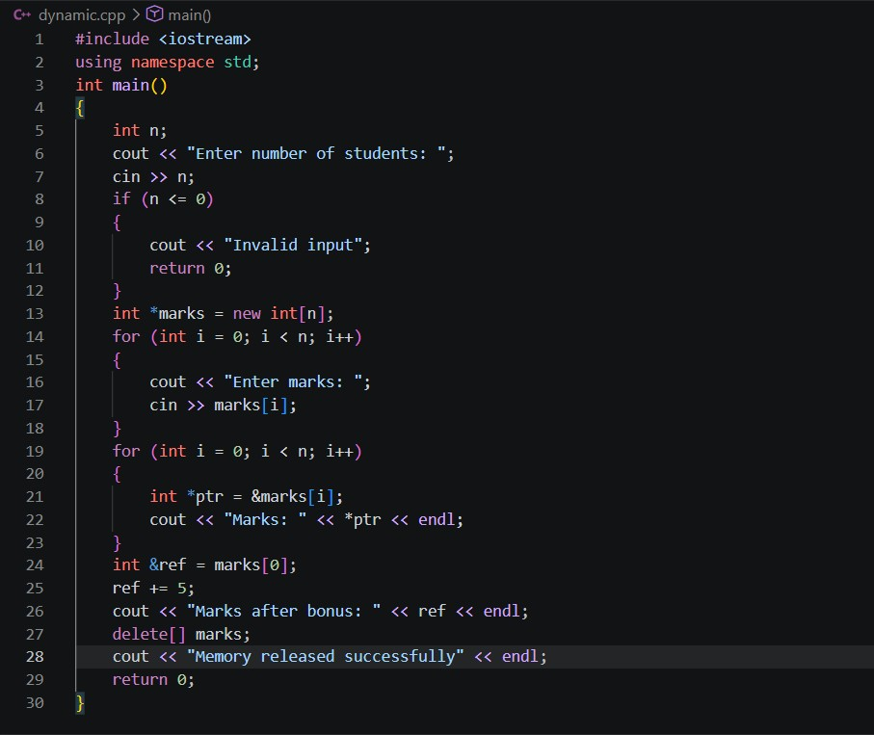
Output:
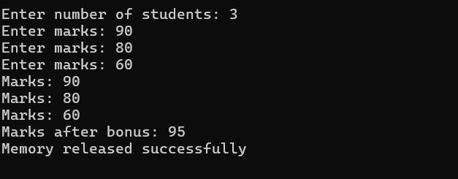

12. Conclusion
This practical helped me understand pointers, references, and dynamic memory allocation in C++. I learned how to access and modify data using pointers and references and how to allocate and release memory dynamically.

13. Assignment Questions
Q1. __________________________________________________________________________
Answer:
__________________________________________________________________
__________________________________________________________________
__________________________________________________________________
Q2. __________________________________________________________________________
Answer:
__________________________________________________________________
__________________________________________________________________
__________________________________________________________________

14. Student Declaration
I hereby declare that the above practical work has been completed by me and that the implementation, analysis, and answers are my own work.
Student Name | PRN | Signature
Pratik Akrur Pandit | 202501110116 | 